[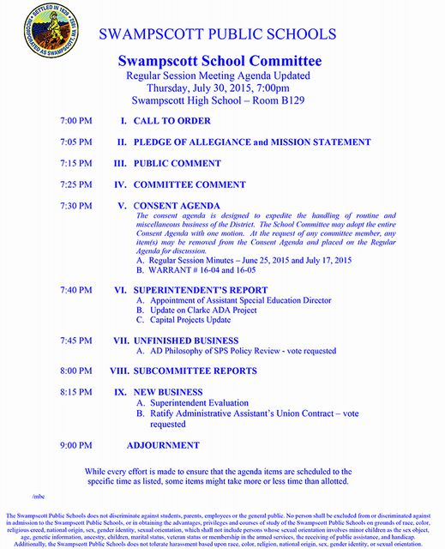](http://www.town.swampscott.ma.us/Public_Documents/SwampscottMA_Calendar/S051E0770-051E6589.0/Updated%20Agenda%2030-July-2015%20SC%20Meeting.jpg)